
Lab 01
Topic | File System & Introduction to Database
Objective | - Data Organization: Understand how to structure and store student information in a CSV file format, mimicking a relational database table.  - Database Operations: Implement basic database operations, including data insertion and retrieval, by writing and reading from CSV files as a simple database.  - Data Filtering: Develop skills to query data based on specific criteria, such as filtering students with a CGPA of 3.5 or above, to simulate SQL query operations.  - Data Relationships: Learn to establish and utilize relationships between different data entities (e.g., employees and departments) by processing multiple CSV files, enhancing the understanding of database normalization concepts.
Learning Outcomes of This Lab:
After completing this lab, students will:
- Understand difference between File System and DBMS.
- Understand relational model basics.
- Understand tables, rows, columns.
- Perform basic database operations using C++.
- Handle CSV files like simple databases.
- Prepare foundation for SQL in upcoming labs.

Introduction to Database
What is Data?
Data is raw facts and figures.
Example:
- Name: Ali
- CGPA: 3.45
- Age: 21
When data is organized properly, it becomes information.

What is a Database?
A Database is an organized collection of related data stored in a structured way so it can be:
- Easily stored
- Easily accessed
- Easily updated
- Easily managed
Example:
A university database stores student records like:
- Registration Number
- Name
- Program
- CGPA
- Contact Number
Instead of keeping this data in notebooks or separate files, it is stored in structured tables.

What is DBMS?
DBMS (Database Management System) is software used to create, manage, and control databases.
It allows users to:
- Insert data
- Delete data
- Update data
- Retrieve data
- Apply conditions (filter data)

Examples of DBMS:
- MySQL
- Oracle Database
- Microsoft SQL Server
- PostgreSQL

File System vs DBMS
Before DBMS, data was stored in simple files. This approach is called the File System Approach.
A. File System Approach
In this system:
- Each department stores its own files.
- Data is duplicated.
- No proper relationship between files.

Problems in File System
- Data Redundancy Same data stored multiple times.
- Data Inconsistency If one file is updated and another is not, data becomes incorrect.
- Security Issues No proper access control.
- Difficult Data Retrieval Searching data is slow and manual.

B. DBMS Approach
In DBMS:
- Data is stored in tables.
- Data is stored only once.
- Relationships are properly defined.
- Multiple users can access safely.

Advantages of DBMS
- Reduced redundancy
- Data consistency
- Better security
- Easy data retrieval
- Multi-user support

Relational Model
The most commonly used database model is the Relational Model.
It was proposed by: Edgar F. Codd in 1970.
In this model:
- Data is stored in tables.
- Tables are connected using keys.

Example Table (Students):

RegID | Name | CGPA
001 | Ali | 3.2
002 | Sara | 3.8
Here:
- Table = Relation
- Each row = Tuple
- Each column = Attribute
Introduction to CSV Files
Before learning real DBMS, we simulate a database using CSV files.
What is CSV?
CSV = Comma Separated Values
It is a simple text file where:
- Each row represents a record.
- Values are separated by commas.
Example:
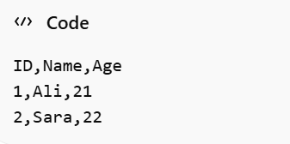

CSV acts like a simple table.

File Handling in C++
In this lab, we use C++ to manage CSV files.
C++ provides file handling using:
Class | Purpose
ifstream | Read from file
ofstream | Write to file
fstream | Read and write

Header file used:
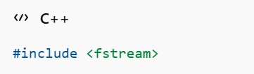
Basic File Operations:
1. Create & Write
- Use ofstream
- Creates file if not exists
- Overwrites existing data
2. Read
- Use ifstream
- Read line by line
3. Append
- Use ofstream with ios::app
- Adds data without deleting old data
4. Delete
- Use remove() function

Operations
- Creating and Writing a CSV File (create_write_csv.cpp)
This program creates a new CSV file (data.csv) and writes some initial data to it.
Steps:
- Open a file in ofstream mode.
- Write column headers (e.g., ID,Name,Age).
- Insert sample records.
- Close the file.

#include <iostream>
#include <fstream> // Include file handling library

using namespace std;

int main() {
string filename = "data.csv"; // Define the CSV file name

// Step 1: Create and open a file using ofstream
ofstream outFile(filename);

if (outFile.is_open()) {
// Step 2: Write column headers to the CSV file
outFile << "ID,Name,Age\n";

// Step 3: Write data rows to the file
outFile << "1,John Doe,25\n";
outFile << "2,Jane Smith,30\n";
outFile << "3,Michael Brown,28\n";

// Step 4: Close the file
cout << "CSV file created and written successfully.\n";
outFile.close();
} else {
cout << "Error creating CSV file.\n";
}

return 0;
}

Output
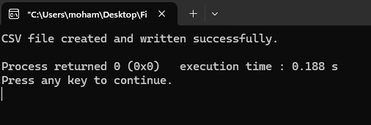
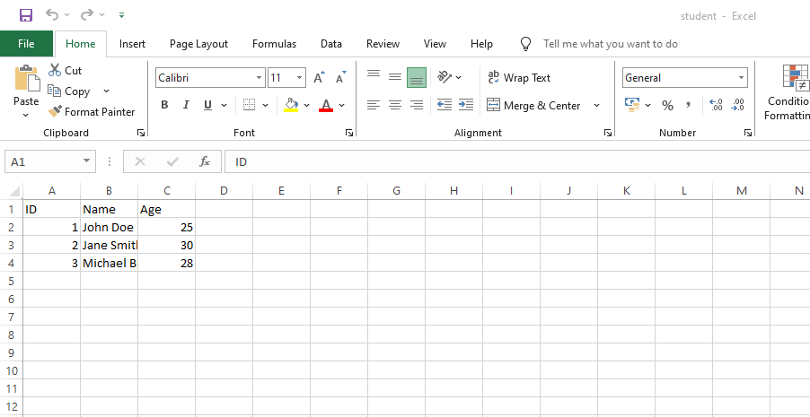

- Read Data from CSV File (read_csv.cpp)
Instructions:
- Include the file handling library.
- Include the string handling library.
- Define the filename (data.csv).
- Open the file using ifstream.
- Read each line from the file.
- Print the line to the console.
- Close the file.

#include <iostream>
#include <fstream> // Step 1: Include file handling library
#include <string> // Step 2: Include string handling library

using namespace std;

int main() {
string filename = "data.csv"; // Step 3: Define the CSV file name

// Step 4: Open the file using ifstream
ifstream inFile(filename);

if (inFile.is_open()) {
string line;

// Step 5: Read the file line by line
cout << "Reading CSV file:\n";
while (getline(inFile, line)) {
cout << line << endl; // Step 6: Print each line
}

// Step 7: Close the file
inFile.close();
} else {
cout << "Error opening CSV file.\n";
}

return 0;
}

Output
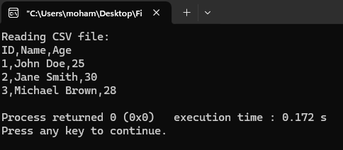

- Append data to CSV File (append_csv.cpp)
Instructions:
- Include the file handling library.
- Define the filename (data.csv).
- Open the file in append mode (ios::app).
- Append new rows without erasing existing data.
- Close the file.
#include <iostream>
#include <fstream> // Step 1: Include file handling library

using namespace std;

int main() {
string filename = "data.csv"; // Step 2: Define the CSV file name

// Step 3: Open the file in append mode using ofstream
ofstream outFile(filename, ios::app);

if (outFile.is_open()) {
// Step 4: Append new data rows to the file
outFile << "4,Emily Davis,27\n";
outFile << "5,Robert Wilson,35\n";

// Step 5: Close the file after appending
cout << "Data appended successfully to CSV file.\n";
outFile.close();
} else {
cout << "Error opening CSV file for appending.\n";
}

return 0;
}
Output
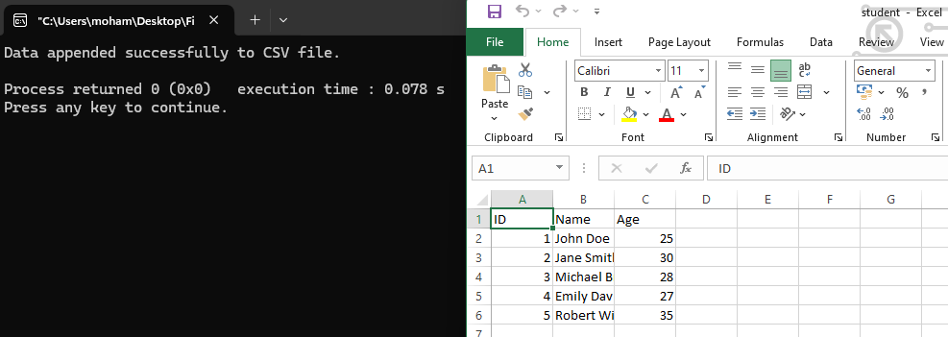

- Deleting a CSV File (delete_csv.cpp)
Instructions:
- Include the standard I/O library.
- Define the filename (data.csv).
- Use remove(filename.c_str()) to delete data.csv.
- Print a success message if deletion is successful.
- Print an error message if deletion fails.

#include <iostream> // Step 1: Include standard input/output library

using namespace std;

int main() {
string filename = "data.csv"; // Step 2: Define the CSV file name

// Step 3: Use the remove() function to delete the file
if (remove(filename.c_str()) == 0) {
cout << "CSV file deleted successfully.\n"; // Step 4: Print success message
} else {
cout << "Error deleting CSV file.\n"; // Step 5: Print error message if file deletion fails
}

return 0;
}
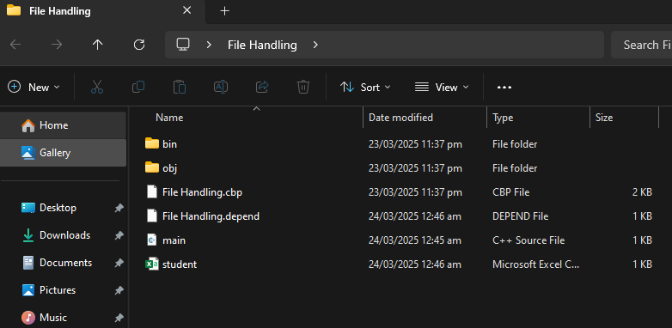
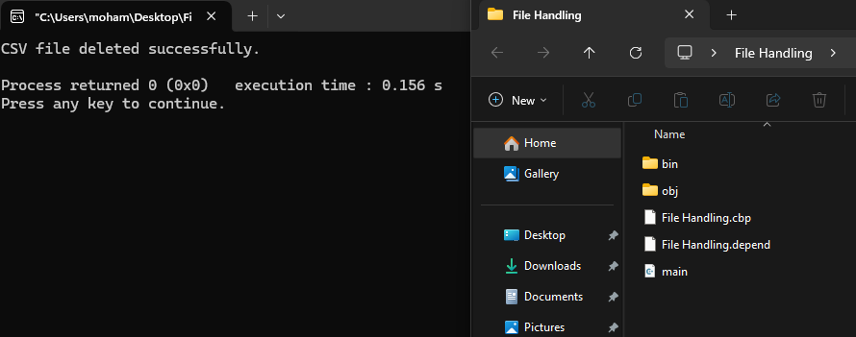

Lab Tasks

Task 01
Library Books Inventory System (CSV)
Scenario:
A library maintains a list of books in a CSV file. Each book has the following details:
Attributes to store:
BookID, Title, Author, Genre, Price, Available Copies
(LibraryBooks.csv):
BookID, Title, Author, Genre, Price, Available Copies
1, The Alchemist, Paulo Coelho, Fiction, 999, 10
2, Introduction to Algorithms, Thomas Cormen, Education, 4500, 5
3, Python Crash Course, Eric Matthes, Programming, 2800, 7
Tasks to Implement:
- write_library_books.cpp: Create and write book records.
- read_library_books.cpp: Read and display all books.
- append_library_books.cpp: Append new book entries.
- delete_library_books.cpp: Delete the book inventory file.
Solution:

To Write
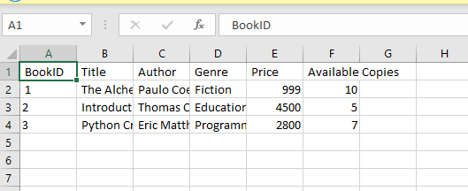

To Read

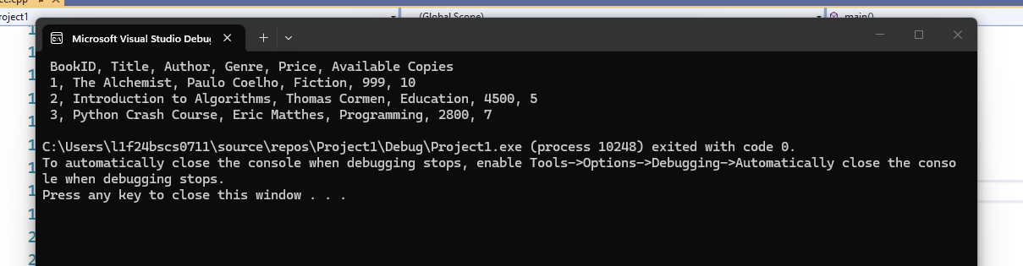

To Append
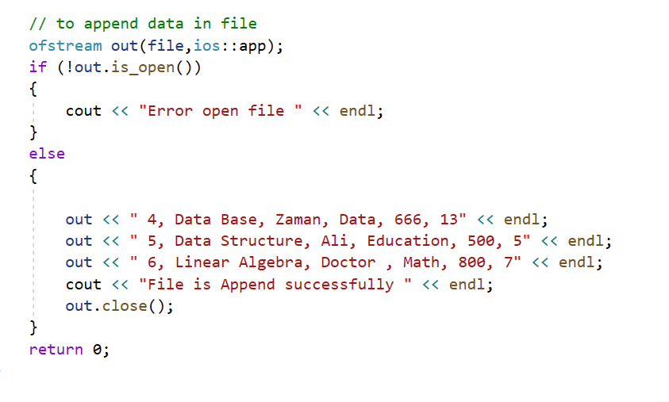
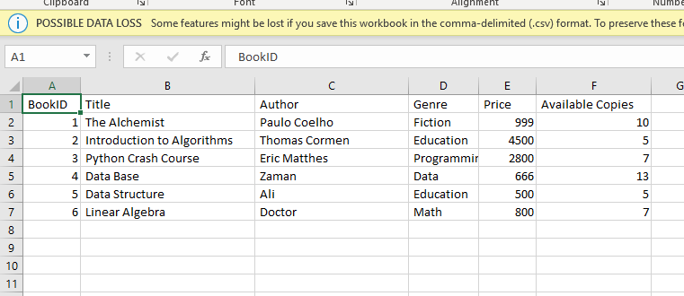

To Delete
